**CLASS TASK**

**COMSATS University Islamabad**

Sahiwal Campus



***Usama Sarwar***

FA17-BS(CS)-090-B

***Ms. Azka Mehmood***

Artificial Intelligence

November 26, 2020

Table of Contents

1. Question 1 1

1.1 Applied Alpha Beta Pruning 2

1.2 Applied MiniMax Procedure 2

1.2.1 Observation 3

# Question 1

Statement: Apply Alpha Beta Pruning and MiniMax Procedure on the following tree, compare the results and write your observations.

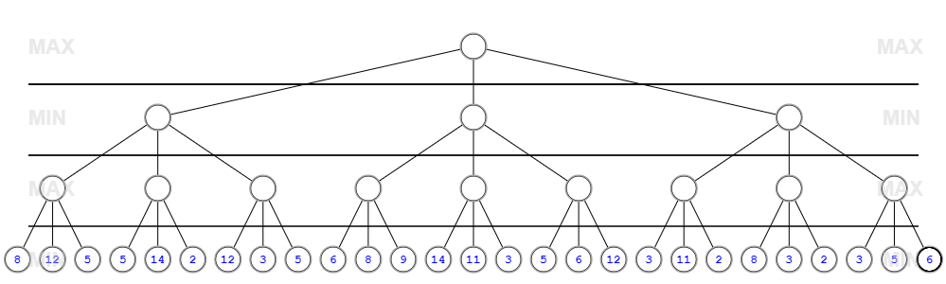

## Applied Alpha Beta Pruning

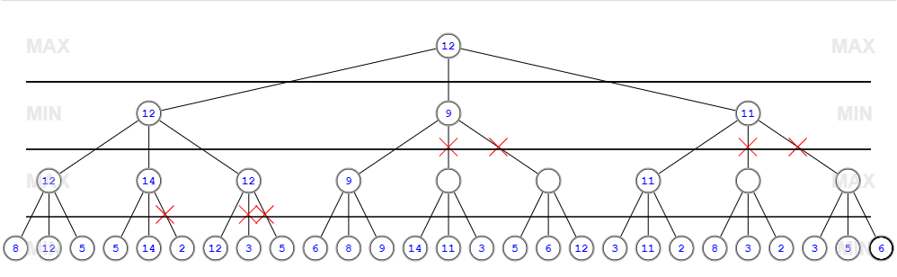

## Applied MiniMax Procedure

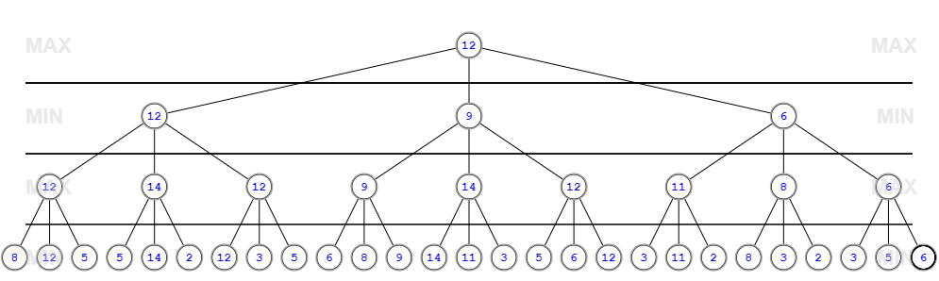

## Observation

In Alpha-beta pruning we reduced the amount of computation and searching during minimax. Whereas Minimax is a two-pass search, one pass is used to assign heuristic values to the nodes at the ply depth and the second is used to propagate the values up the tree. Alpha-beta search proceeds in a depth-first fashion.